

**Global economic tsunamis: Coincidence, common shocks or contagion?**

Speech given by

Kristin Forbes, External MPC Member, Bank of England

Imperial College, London 22 September 2016

Thanks to Ida Hjortsoe and Tsveti Nenova for playing key roles in putting together the analysis discussed in these comments. Special thanks to Jack Marston as well. Further thanks to Ambrogio Cesa-Bianchi, Will Dison, Glenn Hoggarth, Gareth Ramsay, Marek Razcko,

Matt Roberts-Sklar, James Smith, Alex Tuckett, and Sebastian Walsh for helpful comments.

The views expressed here are my own and do not necessarily reflect those of the Bank of England or other members of the Monetary Policy Committee.

Many countries regularly feel like the hapless fisherman in this iconic print by Katsushika Hokusai (Figure 1). Just as ‘The Great Wave’ in the print suddenly comes out of nowhere to present imposing challenges, countries often feel that they are inundated by surprises coming from other realms. Just as the fishermen feel impotent in the face of the surge of water, policymakers can feel impotent in the face of surges in capital flows and sharp movements in global financial markets. And just as any fisherman will ponder whether there is more they can do to strengthen their boats to better withstand rogue waves, countries must continually consider how they can increase their resilience to surprises that originate elsewhere.

These concerns should be first hand for anyone living in the UK – with the UK having played the role of both the hapless fishermen and the rogue wave over the past decade. In 2008 the UK was overwhelmed by the Global Financial Crisis; challenges in the US housing market and mortgage market quickly spread to the core of the UK financial system and contributed to the sharpest recession since the Great Depression. From 2010 to 2012, the UK was again constantly buffeted by different phases of the euro-area crisis. Periods of stress in the euro area corresponded to declines and volatility in UK equity markets, falls in UK exports to the euro area, tighter credit conditions and heightened uncertainty – all contributing to weakness in consumer spending, investment, and the labour market.1

More recently, positions reversed. The UK fishermen created the wave. Figure 2 shows that as the UK prepared for a referendum on EU membership, the Eurozone stock market began to more closely mirror the UK market. The sharp increase in UK equities just before the vote (when most commentators increased the odds of a ‘remain’ result), and then the sharp fall in UK equities (when the surprise outcome to ‘leave’ was announced), were both quickly reflected across the channel. But then the wave seemed to lose energy.

Equity markets in the UK and euro area began to diverge in a pattern more typical before the run-up to the referendum. Why did the ‘Great Wave’ emanating from the UK referendum turn into more of a small boat wake that quickly dissipates?

This talk will explore why countries are sometimes highly vulnerable to major events that occur outside their borders, while at other times seem fairly immune. Why do some negative events turn into global tsunamis – while others are just local ripples?

For example – consider 2 major periods of stress in the global economy: the Asian Crisis (1997-98) and the Global Financial Crisis (2008-2009). Figure 3 shows equity indices during these events for the region/country where the stress originated (in red), plus other major country groups. The Asian Crisis corresponded to sharp falls in equity indices for the Asian economies under stress (not surprisingly). These falls were mirrored

1 For a detailed description of the channels through which the euro-area crisis affected the UK, see [‘EU membership and the Bank of England‘](http://www.bankofengland.co.uk/publications/Documents/speeches/2015/euboe211015.pdf) (October 2015), pp. 64-67. See also the speech

[‘A Tale of Two Labour Markets: the UK and the US‘](http://www.bankofengland.co.uk/publications/Documents/speeches/2016/speech875.pdf) (January 2016) which discusses how the euro-area crisis may have contributed to the stop-start recovery in the UK labour market from 2010 through 2012.

(albeit to a lesser extent) in the advanced economies outside the euro area, but seemed to have minimal effect on other emerging markets. The euro area seemed immune to the Asian wave, with sharply higher – instead of lower – returns. In contrast, the Global Financial Crisis sharply affected equity indices not only in the US, but in all country groups. The equity indices for all groups are basically on top of each other for almost a year from June 2008; the Global Financial Crisis is aptly named and was clearly a global tsunami.

Did these disparate spillovers in equity markets correspond to similar patterns for what people in these countries care about most – real incomes and growth? Figure 4 shows GDP growth to answer this question. The Global Financial Crisis continues to merit its name – corresponding to precipitous and simultaneous declines in growth in each region, followed by simultaneous rebounds. Patterns during the Asian Crisis, however, are quite different than for equity markets. GDP growth in the advanced economies is stronger and more stable than implied by the falls in this group’s equities. GDP growth in the other emerging markets is more negatively affected than implied by the relative stability in their equity markets. And growth in the euro area is middle of the pack – showing none of the outperformance suggested by the region’s strong equity returns.

This lecture attempts to better understand these different patterns of global spillovers – especially during periods of economic stress. It addresses a number of questions. Why do economic tremors in one country sometimes evolve into devastating tsunamis in others – and sometimes fade into small ripples? When do international spillovers in financial markets also harm incomes and economic growth? How have these relationships evolved over time? And perhaps most important, how can countries create ‘tidal breaks’ against these powerful waves originating outside their borders?

The results have important implications for investors and policymakers. I’ll start with investors as many of you in this room are considering careers in finance and should be aware of what you may be up against. I’ll show you that equity markets around the world move together much more closely now than in the past. This makes it more difficult for investors to diversify their portfolios and to generate returns through ‘alpha’ (differentiating oneself from average market movements). I will also provide some insights on why this has been happening and what to watch to predict when these patterns change. A common, global factor has been playing a more important role in causing markets to move together. This is affected by changes in global risk sentiment, commodity prices, and changes in US monetary policy, with events in China recently playing a more important role. Particularly striking, equity markets around the world seem to all respond in more similar ways than in the past to these global factors. It is as if they are all now sailing in the same type of boat.

This analysis also has important implications for policymakers. Policymakers are continually concerned that negative shocks originating abroad will spread to their own shores. This analysis helps understand when this

concern is more likely to become a reality – and exactly what to be concerned about. It shows that sharp reactions in financial markets should be put into context. These movements certainly matter – but the international spillovers to growth and incomes tend to be much smaller than in financial markets. For policymakers concerned about supporting and stabilizing domestic incomes in the face of these external waves, this is good news. The waves emanating from abroad in financial markets can be imposing – and do have important domestic effects – but these effects on the real economy are usually more muted.

Finally, and perhaps most important, although policymakers can usually do little to stop the events that generate waves abroad, they should not despair. Certain policies can make a country more resilient. Steps such as reducing leverage and strengthening banking systems can mitigate the effects of dangerous international waves. Even though fishermen are unable to affect the weather, and unable to completely avoid large waves, they can strengthen their ships and thereby better withstand choppy waters.

The remainder of my comments are divided into four parts. First, I’ll look at how country comovement and spillovers have changed over time. Second, I’ll try to explain these changes by looking at three possible explanations: coincidence (a statistical issue related to how comovement is calculated), common shocks (when the tsunami has a widespread global impact), and contagion (when the wave originates in one country or region and then spreads to others). Third, I’ll explore how countries can mitigate the negative impact of

these waves that originate abroad. Finally, I’ll summarize key results and discuss implications for UK monetary policy – especially in light of the vote to leave the European Union. Is there a chance that the ripple effects associated with leaving the EU turn into a larger wave that causes other countries to wobble – or even capsize – resulting in spillbacks to the UK?

### The Basics: Understanding the Waves over Time

We just looked at how equity markets and GDP growth moved together during two crisis periods. How do these relationships compare to those we observe over longer periods of time? Are the ‘waves’ leading to more or less comovement over time?

To begin, it’s useful to start by looking at the correlations in equity returns and GDP growth for pairs of countries at different points in time. This is a colourful way to capture a substantial amount of information – but takes a bit of explaining. Let’s start with Figure 5a, which shows the correlations in equity returns for pairs of countries around the world from 1985 through 1994.2 Equity returns are a useful place to start as they should incorporate all available information on the expected future profitability of companies in a country –

2 Equity returns are calculated based on local currency returns on a weekly basis for 48 countries. Data is from Global Financial Data for the period 1980-July 2016. The indices used are the broadest equity benchmarks available for each country, with the exception of the UK, where the mid-cap FTSE 250 is used to avoid issues related to the inclusion of large multinational companies in the broader FTSE All-Share index.

and therefore capture expected changes in real indicators. Each cell in the chart shows the correlation in equity returns between the country on the x-axis and the country on the y-axis. A redder colour denotes a higher correlation (i.e. tighter comovement); yellow is lower; green is close to zero; and blues are negative correlations (with the exact numerical definitions to the right). Countries are also grouped by region, with 12 euro area markets closer to the origin, 20 emerging markets at the top and far right, and the 16 other advanced economies in the middle. To take a concrete example, the top right corner is dark red – as it

shows 100% correlation between the Venezuelan market with itself. This is expected for all values on the 45 degree axis. Just to the left of this is the correlation of Venezuela’s equity returns with Turkey’s over this period; this is light green, indicating very little comovement between these two markets over this period. The white is areas without enough data to calculate the correlations.

Don’t worry – I don’t expect you to read the details on the graphs or focus on any individual, microscopic cell. Instead, the main purpose of these graphs is to capture broad trends over time. What do they tell us? Figure 5a has a lot of light green and yellow, suggesting little comovement between most countries’ equity returns – especially for emerging markets around the edges. There is some orange and a few red cells in the section for the euro area and other advanced economies, suggesting somewhat higher comovement between some countries in these groups. Most of the red cells are intuitive as they show countries that are closely linked – such as the cell showing the comovement between the US and Canadian markets.

Now, let’s look at how the diagram changes over time. Figure 5b shows the same correlations over the following decade – from 1995 through 2004. There is now more red and orange scattered throughout the graph, especially in the bottom block with countries from the euro area. This suggests comovement in equity markets has increased, especially in the euro area. This increased comovement in the euro area during this period is not surprising; it is when the common currency was introduced and trade and financial flows within the region increased rapidly.

Continuing our travel through time, Figure 5c shows the same correlations during the Global Financial Crisis, from 2008 through 2010. It is as if we just jumped through hyperspace to another, much hotter, universe. The graph is almost entirely red—even across most emerging markets. Equity markets around the world moved together extremely tightly over this period.

Finally, Figure 5d shows what the world looks like today – or at least from 2010 through to July 2016. Equity returns still move together tightly around the world – and much more so than before 2005. Even though this comovement is not quite as strong as during the Global Financial Crisis, countries’ equity markets appear to be more tightly linked than they have been historically. The euro area (in the bottom left) continues to show the highest degree of comovement, and the emerging markets (on the top and right) the least – albeit still substantially more than before the crisis.

Do the same patterns hold for GDP growth? Figure 6 shows the same bilateral correlations over the same periods, except now for GDP growth. The comovement in GDP growth from 1985-1994 is very low, and the heat map gets only slightly ‘warmer’ from 1995-2004. Then Figure 6c shows a jump to a very hot universe during the Global Financial Crisis – with the map largely turning red as seen for equities. But then, in contrast, the graph for growth correlations over the most recent period shows a sharp cooling since 2010 – to an overall colouring that looks quite similar to that observed from 1995-2004. GDP growth rates around the world have not been moving together tightly. In fact, all of the GDP graphs tend to be less ‘hot’ than the corresponding graphs for equities. The tight comovement in equity markets does not correspond to tight comovement in growth rates – except during the Global Financial Crisis. Although the comovement in equity markets has been increasing over time, this has not occurred for GDP growth, where the comovement is instead at low levels.

These graphs are always fun to look at – and good at capturing general trends – but can be hard to interpret concisely. The sharp changes seen during the short window around the Global Financial Crisis also suggest that looking at these average correlations over a decade could mask important changes within these long windows. Therefore, it’s also useful to distill these multiple correlations between all the country pairs into rolling averages of these bilateral correlations. The resulting trends are shown in Figure 7, for both equity returns and GDP growth, using the same countries and data and calculated over five-year rolling windows. These average correlations are reported for the full sample (black) and various groups of countries.

These graphs largely confirm the patterns in the colourful charts. Panel a shows a fairly steady increase in equity correlations over time – especially during the Global Financial Crisis when the average correlation increased to more than 60% for the full sample. Correlations have fallen back some since, but are still elevated relative to pre-crisis levels. In fact, if you drew a trend line reflecting the upward movement in the correlations since 1980 and ignored the temporary spike during the crisis, the trend line would have predicted the high levels of comovement that we see today for the full sample. Investors complaining about the increased comovement in equity markets are justified; equity markets are moving together more tightly than in the 1980s, 1990s, and early 2000s.

In contrast, Panel b shows that this complaint does not apply to countries’ growth rates. The comovement in GDP growth rates increased sharply during the crisis – albeit to lower levels than for equity markets. There is, however, no apparent trend over time. The small increase in average correlations in the early 2000s has reversed, and instead growth correlations in all countries except the euro area have recently fallen back to levels not seen for at least 15 years. In fact, for the full sample of countries, these correlations are now close

to zero – suggesting little comovement in growth rates around the world recently. This low degree of growth comovement provides a sharp contrast to the nearly 50% correlation currently observed in equity markets.3

To summarize, the two approaches to measuring country comovement yield the same conclusions. Countries’ equity markets are increasingly in the same boat. Movements in equity returns in one nation correspond to similar movements in others – and these links have been growing over time.

In contrast, changes in GDP growth in one nation are much less likely to correspond to similar movements in others. Other than during the Global Financial Crisis, and in the euro area today, countries’ GDP growth rates are sailing in different directions and seem to be buffeted by different winds.

### Why are we all in the same boat?

Why do equity markets seem to be affected by the same wind today – but not growth rates? Why did growth rates suddenly start to capsize together during the Global Financial Crisis? Why do equity markets seem to be sailing in tighter and tighter formation over time?

There are a number of possible explanations. I’ll focus on three today: coincidence, common shocks, and contagion. By coincidence, I mean a statistical issue in how comovement is measured, which can cause correlation coefficients to increase and heat maps to look ‘hotter’– without actually corresponding to tighter comovement. By common shocks, I mean changes in the global environment that affect all countries simultaneously – such as changes in oil prices. Returning to the nautical analogy, have the global waves gotten bigger and/or do they wash over more countries than in the past? By contagion, I mean bad news in one country (or region) that spreads to others. If one ship goes down, is it more likely to drag others with it? There are also other, related explanations for the higher cross-country equity comovement, such as the inclusion of more multinational companies in local indices, the growing international exposure of multinationals, or the listing of some companies in international financial centres rather than on their national exchanges. Although these factors have undoubtedly played some role, especially in markets that are attractive for international listings, I will not focus on these explanations today as they are unlikely by themselves to explain the increased comovement between the range of markets in the wider sample of countries considered.

Separating out these potential explanations is extremely difficult. There have been many heated debates in the academic world over how to define and measure ‘common shock’ versus ‘contagion’ versus

3 The different magnitudes of the correlations between equity returns and GDP growth rates do not result from the fact that the equity correlations are calculated based on weekly data, while the growth correlations are based on quarterly data. Estimating the equity correlations with quarterly data yields similar numbers.

‘comovement’.4 And the ‘coincidence’ that I’ve added is my rather unimpressive attempt to continue with the ‘c’ alliteration. Policymakers frequently remind academics that if their country is doing everything

more-or-less right, and then they are swept off course by events that originate elsewhere, they don’t care whether it is ‘normal comovement’ with a close partner, or ‘contagion’ from a country half-way around the world, or a ‘common shock’ that affects everyone. I will not pretend to resolve these debates tonight. Instead, I’ll show you some different approaches and evidence to get a sense of what is going on in the heat maps.

This will go some way to understanding these trends over time and the differences in comovement between financial markets and GDP growth.

### Coincidence (of statistics)

One reason why markets may appear to move together more tightly now than in the past is a ‘coincidence’ that results from a statistical property. Straightforward algebra shows that when volatility increases, correlation coefficients and comovement automatically seem to increase.5 Hopefully all of you in this room who are studying finance are already aware of this statistical relationship caused by heteroscedasticity. It is too late in the evening to put you through the algebra, so instead I’ll use a simple coin example to illustrate this point.

To begin, suppose that there are two rounds to a game. In the first round you flip one coin. If it is heads, you win, and if it is tails, you lose. This round can be played with either a penny or a special £100 coin. In the second round, you also flip a coin and win with heads and lose with tails, but now the coin doesn’t change and is always a 20-pence coin. What you win or lose depends on what you toss in both rounds; you get (or owe) ten percent of the outcome of the first round plus the entire outcome of the second round. The outcome of the game when you play with a penny is shown below.

#### *Coin Scenario 1*

|  |  |  |  |  |
| --- | --- | --- | --- | --- |
| **ROUND 1**  **(pence)** |  | **ROUND 2**  **(twenty pence)** |  | **PAYOFF**  **(in pence)** |
| Heads (+1) |  | Heads (+20) |  | +20.1 |
| Heads (+1) |  | Tails (-20) |  | -19.9 |
| Tails (-1) |  | Heads (+20) |  | +19.9 |
| Tails (-1) |  | Tails (-20) |  | -20.1 |

*Payoff is (10% x outcome of round 1) + outcome of round 2*

4 See Forbes (2013).

5 This general result is known as the Normal Correlation Theorem. To the best of my knowledge, the first person to highlight this result was Rob Stambaugh in a discussion of Karolyi and Stulz (1996). This coin example and a more extensive discussion of the implications

for measuring contagion are in Forbes and Rigobon (2001, 2002).

Since the payoff is equal to the outcome of the second round (plus or minus 20 pence) plus or minus a tenth of a penny, the outcome of the first coin toss has a negligible impact on the payoff. Therefore, when the first round is played with a penny, the correlation between the first round and the payoff is close to zero (0.5% to be exact) and the outcomes of the first round and payoff are almost independent.

On the other hand, when the first round is played with a £100 coin instead of a penny, the possible scenarios are (again in pence):

#### *Coin Scenario 2*

|  |  |  |  |  |
| --- | --- | --- | --- | --- |
| **ROUND 1**  **(£100 coin)** |  | **ROUND 2**  **(20 pence)** |  | **PAYOFF**  **(in pence)** |
| Heads (+10,000) |  | Heads (+20) |  | +1020 |
| Heads (+10,000) |  | Tails (-20) |  | +980 |
| Tails (-10,000) |  | Heads (+20) |  | -980 |
| Tails (-10,000) |  | Tails (-20) |  | -1020 |

*Payoff is (10% x outcome of round 1) + outcome of round 2*

The payoff is now equal to the 20-pence outcome of the second round plus or minus ten pounds. In this case, the outcome of the second toss, instead of the first, has a negligible impact on the payoff. The correlation between the first round and the payoff is now almost one (99.98% to be exact).

The critical point of this exercise is that in both the penny and the £100 scenario, the effect of the result or ‘shocks’ from the first toss to the payoff is always ten percent. The correlation coefficient, however, increases from almost zero in the penny scenario to almost one in the £100 scenario.

This coin example is directly applicable to measuring the transmission of shocks across countries. The first coin toss represents a country which goes through periods of low volatility in its returns or growth (when the first toss is with the penny) or high volatility (when the first toss is with the £100 coin). You can think of the low volatility game with the penny as a stable period, while getting a tails in the high-volatility game with a

£100 coin is when a crisis occurs. The second toss represents the second country; this round is always played with a 20-pence coin, but the payoff (i.e. the final equity return in the second country) depends on the outcome in the first country. As the coin example clearly shows, even though the underlying transmission mechanism from the first country to the second country remains constant (at 10 percent) in both scenarios, the correlation in returns increases significantly after the crisis outcome. Correlation coefficients increase – but there is no fundamental change in how the countries commove or how the shocks from the first country are propagated to the second.

This statistical fact that greater volatility automatically causes correlations to increase – and heat maps to get hotter – is undoubtedly a factor driving the sharp increase in both equity and growth correlations during the Global Financial Crisis. Markets were extremely volatile during this period.

But could greater volatility and this statistical property also be driving the broader increase in equity market comovement since the 1980s? Could it be driving the increase in growth comovement in the euro area?

A quick way to test if this could be a factor is to simply look at the volatility in equity markets, GDP growth and the euro area over time. If volatilities did not increase when correlations increased, then this statistical ‘coincidence’ is not the main story.

Figure 8 therefore graphs the volatility in equity returns and GDP growth (measured by 5-year rolling standard deviations) for the full sample and different country groups. It confirms that the volatility in each of these measures increased during the Global Financial Crisis, and that this drove at least some of the ‘warming’ in the heat maps and increase in the correlations over this period. Volatility in the euro area is slightly higher than in the other country groups – suggesting this may play a small role in explaining the higher correlations in equity and GDP growth in this region recently.

Most striking about these graphs, however, is the low levels of volatility since the Crisis for both equities and GDP growth. In fact, volatility has recently been no greater than typically observed from 1985 through 2005. This suggests that increased volatility is not driving the longer term trend of equity markets moving together more tightly over time. It does not even seem to closely mirror the changes in correlations in GDP growth within the euro area. Deeper economic currents seem to be at play.

### Common Shocks

Another potential explanation for the changes in comovement in equity markets and GDP growth over time is changes in the role of common shocks. Are there global events (such as swings in oil prices, changes in global risk aversion, adjustments in US monetary policy, or changes in China’s economic outlook), that simultaneously affect many countries around the world and cause their equity markets to move in sync? Are these waves affecting countries around the world getting bigger? Or do these types of events simply have more of a global impact on equity markets than in the past? For example, has China’s rapid development and progress to become the second largest economy in the world caused it to have greater global effects

than in the past? Or are more countries’ equities being affected by these global events in the same way? In other words, does the global tsunami now travel further and catch more countries in its wake?

To better understand these potential roles of common shocks in explaining some of the patterns we saw earlier, I will use a methodology called rolling principal component analysis. Don’t worry, the name is more intimidating than the concept. What this basically involves is estimating how much of the movement in countries’ equity returns (or growth rates) can be explained by some ‘common’ or shared factors at each point in time. You can estimate the role of the single most influential common factor, or of all common factors that are judged to be important (setting a threshold for what qualifies as important). Then, after estimating this common factor (or factors) – it is straightforward to estimate not only the average country sensitivity to this factor(s), but also the dispersion of sensitivities across countries. This is a rough way of measuring whether greater comovement is driven by bigger common shocks, by greater sensitivity of countries to these shocks that originate elsewhere, or by more similar responses to the global shocks.

Figure 9 shows the result. It shows the share of the variance in countries’ equity returns (panel a) and GDP growth (panel b) that can be explained by shared common factors (principal components). These include all common factors that play an important role – based on a standard statistical threshold used in this type of analysis.6 More and more of the movement in countries’ equity markets correspond to these shared, global components over time. In fact, the upward trend in the graph of the common components roughly mirrors that for the correlation in equity markets over time. For GDP growth, there is less upward trend in the common components (except in the euro area). But the role of these common components spikes for all the country groups during the Global Financial Crisis. Therefore, the patterns in the common components for both equities and GDP growth roughly mirror the patterns seen for the changes in cross-country correlations over time and between the different country groups.

This suggests that shared global or common factors play an important role in explaining the increased comovement in global equity markets over time, as well as the increased comovement in GDP growth rates during the Crisis and in the euro area. This agrees with results obtained in a series of academic papers using a range of different methodologies.7 But it still leaves important questions. When the role of the common factors increases, is it due to larger common shocks (i.e. larger waves), a greater sensitivity of countries to these common waves, or a more similar response to the common waves? And what is driving these common waves?

Starting with the first of these questions, the magnitude of the common shocks appears to be a significant contributor to the higher degree of cross-country comovement. Figure 10a shows that the volatility of

6 Common factors are defined as principal components that affect more than one country for the full period from 1980-2016, with an eigenvalue greater than 1. This definition is standard, see Cesa-Bianchi *et al*. (2016) for a recent application. For further details, see the notes to Figure 9.

7 For example, papers which find that global factors explain an important part of the variance in asset market returns include: Forbes and Warnock (2012), Bruno and Shin (2015), and Miranda-Agrippino and Rey (2015). Fratzscher (2012) and

Milesi-Ferretti and Tille (2011) also find that global ‘push’ factors (basically common factors) were the dominant factor driving portfolio flows during the Global Financial Crisis, but other country-specific factors have been more important since.

common factors behind equity returns has increased since the 1980s and can explain some of the larger share of variance explained in Figure 9.a. Figure 10b shows that the volatility of the common factors driving GDP growth is much more stable, except for a large increase during the Global Financial Crisis.

Figure 11 tackles the other possible explanations for the increased role of the common factors, focusing on results for the full sample (with results for the different country groups in the Appendix). The black lines show the average sensitivity of countries’ equity returns (panel a) and GDP growth rates (panel b) to the most important common factors. In technical terms, this is the average absolute loading on the principal components. The magnitude of this sensitivity to common factors has increased somewhat over time for equities, and more sharply for GDP growth during the crisis, but the movements overall have been fairly small – especially when compared to the changes seen in the other graphs. This implies that the impact of the common shocks has been fairly constant or only changed moderately.

More striking is the movements in the red lines. These capture the extent to which these common factors affect the different countries in different ways. In technical terms, this is the standard deviation of the loading of the principal components. The steady decline in this line for equities indicates that the common factors are affecting more and more countries in a similar way. In other words, an event such as changes in oil prices is now having more similar effects on equity markets around the world. In the past, the effect of a given change in oil prices used to be more differentiated across countries. The corresponding graph for GDP growth (in panel b), shows that these common factors also had more similar impacts on countries’ GDP growth rates during the crisis than before – but this seems to have just been a temporary increase. (The graphs in the Appendix also show that countries in the euro area are affected in a more similar way by common shocks than in the past.)

To summarize, common shocks appear to be an important part of the story explaining the patterns I started with today. The common waves affecting equity markets around the world have gotten larger, and these waves seem to be reaching out further than in the past to wash over more countries in similar ways. The common waves affecting GDP growth have been more stable in size, and continue to reach different countries in different ways (except during the Crisis and in the euro area, when the waves seemed to catch more countries in their wake.)

But what is behind these common waves? Although economists have a clear idea of what they view as a common shock, it is much harder to actually identify, isolate, and estimate in practice. For example – does a sharp fall in oil prices (which tends to affect many countries simultaneously) reflect some sort of change in oil supply (such as from increased US shale production)? Or increased energy efficiency? Or slower growth in China? The latter is more of a country-specific shock in one country (China) – which then spreads to others and is often called ‘contagion’ (and is discussed in the next section).

Despite these challenges, I’ll extend the analysis we just did to try to get a better sense of what is behind these common shocks (or principal components). I’ll estimate a simple regression of the most important common factor (the first principal component) for the full sample period and the full set of countries as a

function of several possible factors that could be driving it: commodity prices, global risk, US interest rates, surprises to expected global growth, and surprises to China’s growth.8

Figure 12 shows the results. Column 1 uses data from 1985 through July-2016, but only includes the first three global variables. Column 2 includes all five variables, but only starts in 2004 (which is the earliest date for the two economic surprise indices). Both columns yield the same results: changes in commodity prices, global risk, and US interest rates all seem to be significant and important factors driving common shocks to equity markets over this long period of time.

What is perhaps more interesting, however, is how these estimates of the common factors affecting equity markets change over time. This is shown in the last three columns of Figure 12. Changes in US interest rates seems to have played a less important role recently – although this may reflect the long period during which US interest rates have been fairly stable and may not persist. In contrast, the role of economic surprises in China has become more important in the most recent window (from 2012 to 2016). This suggests that the main forces driving the common factors affecting global equity markets have been changing over time.

What about for GDP growth? A similar analysis attempting to explain the single most important common factor driving GDP growth in the sample finds no consistently significant factors – over the full period or for shorter windows. This is not surprising. There is much less comovement in GDP growth than in equities. The variance of countries growth rates that can be explained by the most important common factor (the first principal component) is also much lower for GDP growth than equities (as shown in Figure 13). Regression results suggest that the role of the common factor increased during the Global Financial Crisis, and this is correlated with sharply higher global risk aversion and a greater impact of this common factor on countries around the world. During other periods, however, since there is much less comovement in global GDP growth rates, it is not surprising that common global factors play little consistently significant role.

To summarize, common global factors – which are highly correlated with changes in commodity prices, global risk measures, US interest rates, and China’s economic growth – have all played some role in explaining the high levels of comovement in equity prices. The role of China has increased recently.

8 These variables were selected based on the academic evidence, such as: Forbes and Warnock (2012), Forbes (2013), Koepke (2015), and Miranda-Agrippino and Rey (2015). They capture the idea that common factors driving equity returns across countries might include expectations of monetary policy and economic growth in large economies, as well as changes in investor risk aversion (or, more formally, time-varying equity risk premia).

Changes in these global variables are affecting more countries around the world in similar ways than in the past. The global wave is catching more and more fishermen.

### Contagion

In addition to common shocks, contagion may also play a role in explaining increased comovement in equity markets around the world, as well as increased comovement in GDP growth during the Crisis and in the euro area more recently. Economists have argued extensively about how to define contagion, but the latest working definition is when bad news in one country spreads to others.9 This is the same idea as the use of the term contagion in the medical literature; when a disease spreads from one person to others. In the context of the tsunami example, this is basically when a big wave starts in one country (instead of in a common ocean) and then hits others. Since good news lifts all boats – but the bad news of a disease or tsunami can be deadly – policymakers usually only use the term contagion to explain the spread of bad economic news.

Contagion has always been a concern globally.10 For example, in 1825 a banking crisis started in Britain and quickly spread to continental Europe and then to Latin America. In 1857 the direction of transmission reversed, when a banking panic in the United States spread to the United Kingdom, continental Europe, and then regions as far away as South America, South Africa and the Far East. But has this tendency for bad news to spread globally increased over time? Could this explain some of the comovement patterns documented earlier?

To better understand if bad news tends to spread more widely than in the past, a useful measure is the ‘joint coincidence of extreme negative returns’.11 Yes – that is a mouthful. Yes – it sounds as bad as what it is trying to capture. But the actual statistic it represents is less complicated than the name. To calculate this

statistic, you need to first decide what you think qualifies as a ‘very bad’ event, *i.e.* an extreme negative return. I typically use the definition of events in the bottom 5% of the distribution, *i.e.* the 5 worst episodes of whatever you are looking at out of every 100. Then you calculate what percent of the countries in your sample have this ‘very bad event’ at the same time. That’s all. It’s a succinct way of capturing what fraction of countries are all being hit by the tsunami at the same time.

Figure 14 shows this measure – the share of the sample that has an extreme negative equity return or growth rate –in each week since 1980 for equity markets (panel a) and each quarter for GDP growth (panel

9 See Forbes (2013) for a discussion of different definitions of contagion and a shift towards this working definition.

Other papers providing analysis of financial market contagion include: Allen and Gale (2000), Claessens and Forbes (2001), Karolyi (2003), Forbes (2004), and Dungey et al. (2010).

10 See Kindleberger (1989) and Bordo and Murshid (2001) for historic examples of financial panics spreading globally.

11 For additional work developing this framework of using the joint coincidence of extreme negative returns to measure contagion, see: Bae *et al*. (2003), Forbes (2013), and Londono (2016).

b). I’ll just focus on results for the full sample, as results are similar for the different subgroups (albeit with slightly more extreme negative returns recently in the euro area). If countries’ extreme negative returns are purely independent (i.e. they result purely from idiosyncratic shocks and are not related to events in other countries or global shocks), then about 5 percent of the sample should experience extreme negative returns in each period.

That is clearly not the case. There is nothing close to a steady line of bars equal to 5 percent. Instead, there is substantial volatility in the bars and several spikes when a large percentage of the sample has extreme negative returns. For example, during the Global Financial Crisis, about 90% of the countries in the full sample had an extreme negative equity return and about 70% had an extreme negative quarter of growth. When countries experience bad economic news, they are often not alone.

A closer look also suggests some subtleties. The bars are larger for equities than GDP growth, suggesting that bad news is more likely to occur simultaneously in equity markets than in growth rates. The large bars also seem to be more common later in the sample than earlier for equity returns – suggesting bad news is more likely to occur simultaneously now than in the past. In contrast, for GDP growth there does not appear to be an increase in extreme negative returns later in the sample, except for the period around the Global Financial Crisis. During bad times, equity markets seem to move together more tightly than GDP growth rates – just as occurs during longer periods that include both good and bad times.

But the bars also bounce around so much that it is difficult to draw strong conclusions; it is also difficult to compare results for equity markets and growth rates as the first is based on weekly data, while the latter is based on quarterly data. Therefore, Figure 15 tries to make these comparisons more precise by reporting the five-year rolling average of extreme negative returns for as long as the data is available. The percent of the full sample experiencing extreme negative equity returns increased steadily over the 1980s, then again at the end of the 1990s, and then even higher at the end of the 2000s. It has since fallen back to below the level of the 1990s – and even lower for emerging markets. The same graph for GDP growth (panel b) shows the expected increase in the number of extreme negative returns in the late 2000s around the Global Financial Crisis, but then an even sharper decline to below the levels of the 1980’s – for the full sample and each subgroup (except the euro area). There have recently been an unusually low number of countries simultaneously experiencing extremely low equity returns or growth rates. The waters have recently been fairly calm.

This evidence that contagion has recently been more moderate than in the past could reflect a number of different factors. It could simply be the ‘calm before the storm’ – with a round of contagion coming soon. It also could reflect the fact that there has been less ‘very bad news’ that originates in individual countries and spreads or is driven by the common, global variables. Or countries could be more resilient to bad news that

originates elsewhere (something we will explore in more detail below). Overall, the evidence that contagion has not recently increased in equity markets suggests that it has played a less important role than common factors in explaining the trend of increased equity market comovement over time. The higher levels of contagion in both equities and GDP growth in the euro area and during the Global Financial Crisis, however, suggest that contagion has played some role in explaining the higher levels of comovement in these countries and during this crisis period.

To better understand what drives these extreme negative events – and therefore better understand when and how contagion occurs – I will build on the regression analysis I just showed you attempting to explain the factors behind the common shocks. Now, however, I will attempt to explain the probability that a country has an extreme negative return. Table 16, column 1, shows the results for equity markets.12 It finds that the three variables driving the common shocks (changes in commodity prices, global risk, and US interest rates) also play a role in explaining whether a country has a sharp fall in its equity market. The results also include a new variable – the percent of the rest of the sample with an extreme negative equity return at the same time. This variable is a measure of contagion and is consistently important – suggesting that a country is more likely to have a sharp fall in its equity markets if a higher share of other countries are also experiencing sharp falls. Contagion is estimated to be important even after controlling for the variables driving global, common shocks. The importance of contagion holds when the estimates are repeated for different time periods – although the importance of the different global variables tends to change over time.

If I repeat the analysis for growth rates, results are more mixed – as occurred when analysing the common shocks driving GDP growth around the world. The contagion variable is significant in explaining periods of sharply lower GDP growth during the Global Financial Crisis, but often not in other periods. This is not surprising given the earlier graphs of the extreme negative returns. There are few periods when a large number of countries have sharp falls in growth simultaneously, and a low comovement in GDP growth rates during all periods except during the Global Financial Crisis. One would not have expected to see strong contagion effects outside of this window.

To summarize, the evidence in this section suggests that contagion – when bad news in one country (or region) affects others – has played some role in explaining the increased comovement in GDP growth rates during the crisis, and higher levels of comovement in equity markets during all periods. Although contagion does not appear to explain the increased comovement in equity markets over time, it is still important after controlling for the effects of common shocks. Large waves – whether they start in the global ocean or in a specific country – can play powerful roles in causing sharp falls in equity markets and GDP growth. It is no

12 Because extreme negative returns occur irregularly (95 percent of the sample is zeros), these equations are estimated using the complementary logarithmic (or cloglog) framework, which uses the cumulative distribution function (cdf) of the extreme value distribution. Standard errors are also clustered by country.

surprise that countries often feel as powerless against these forces as the fishermen in Hokusai’s famous print.

### How do Countries Strengthen their Boats against Contagion and Common Shocks?

What can countries do to protect themselves against these large waves that originate elsewhere? What characteristics make a country’s boat more resilient to these forces?

There are many country characteristics and policies that might make a country more or less vulnerable. I’ll just focus on three that have received substantial attention in the academic literature and the policy world: openness to trade, openness to capital flows, and bank regulation. More specifically, are countries more vulnerable to shocks that originate outside their borders if they are more open to trade or capital flows? Or if they have more leveraged and less well capitalized banking systems? Since countries tend to worry more about how common shocks and contagion negatively affect them (and less so when they benefit), I’ll focus on how these three characteristics make countries more likely to have sharp falls in their equity markets or sharp slowdowns in growth.

Columns 2 through 5 of Figure 16 show the results for equity markets.13 This uses the same framework used to predict when a country has a sharp negative equity return, but now includes interaction variables to see if trade, financial openness, or banking leverage make a country more vulnerable to sharp negative equity returns that occur elsewhere. I continue to control for the common shocks. The results are intuitive and agree with the findings in the academic literature. Each of the three country characteristics matter and can affect how vulnerable countries are to events that originate elsewhere.14 Countries that trade more and that are more financially open are more affected by bad news in other countries. Other work has shown that these effects tend to be larger if the bad news originates in countries which are more closely linked through trade flows, export competition in third markets, or banking flows.15 Countries with more leveraged financial systems are also significantly more vulnerable to bad news from abroad.

This last result is worth highlighting. Over the last few years, evidence has been accumulating that countries with rapid domestic credit growth and higher leverage are more vulnerable to sharp economic slowdowns and financial crises. Although rapid credit growth and leverage can initially contribute to economic booms

13 The equation estimated is:

*p*𝑟𝑜𝑏(𝐸𝑁𝑅𝑖𝑡 = 1) = 𝐹(𝛽 ∗ 𝐺𝑙𝑜𝑏𝑎𝑙𝑡 + 𝛾1 ∗ 𝐸𝑁𝑅𝐴𝑙𝑙 𝑇𝑟𝑎𝑑𝑒𝑖𝑡 + 𝛾2 ∗ 𝐸𝑁𝑅𝐴𝑙𝑙 𝐵𝑎𝑛𝑘𝐿𝑒𝑣𝑒𝑟𝑎𝑔𝑒𝑖𝑡 + 𝛾3 ∗ 𝐸𝑁𝑅𝐴𝑙𝑙𝐹𝑖𝑛𝑂𝑝𝑒𝑛𝑛𝑒𝑠𝑠𝑖𝑡) , where 𝐸𝑁𝑅 is a

𝑡

𝑡

𝑡

dummy equal to one if country *i* has an extreme negative return in equities or GDP growth in period *t*. This is estimated using the complementary logarithmic (cloglog) framework, with standard errors clustered by country. 𝑇𝑟𝑎𝑑𝑒 is measured as (exports+imports)/GDP. 𝐹𝑖𝑛𝑂𝑝𝑒𝑛𝑛𝑒𝑠𝑠 is measured using the normalized Chinn-Ito measure of capital account openness. 𝐵𝑎𝑛𝑘𝐿𝑒𝑣𝑒𝑟𝑎𝑔𝑒 is the ratio of domestic banks’ claims on the private sector to the value of demand, time, savings and foreign currency deposits, using data from the IMF International Financial Statistics database.

14 See Forbes (2013).

15 See Van Rijckeghem and Weder (2001), Forbes (2004), Forbes and Warnock (2012) and Cesa-Bianchi *et al*. (2016).

and faster growth, they also make a country more vulnerable to bad news.16 Even if the bad news does not seem important enough to have macroeconomic effects, it can be amplified by highly-leveraged banks that need to cut back lending and unwind positions elsewhere.17 The more leveraged a financial institution, the greater reductions it needs to make in its other loans and positions, leading to what has been called

‘liquidation spirals’ or a ‘diabolic loop’. Allen *et al.* (2012) show how this can, in turn, aggravate contagion and increase systemic risk. The bottom line is that when a period of unsustainable credit growth ends and this deleveraging begins, it is magnified in countries with less well capitalized financial systems and can correspond to painful adjustments in consumption, investment, and overall demand and growth.

What does all of this imply for countries hoping to reduce their vulnerability to contagion and common shocks? This is far from the detailed analysis that would be required to support major policy changes – but it does raise three areas that countries could consider: trade, financial openness and banking leverage.

It might be tempting to interpret these results as suggesting that countries should limit their openness to trade or financial flows in an effort to reduce their vulnerability to contagion. Such a leap of logic, however, would ignore the many benefits that trade and capital flows bring to a country.

A long literature has documented the substantial benefits of trade, and it is unlikely that the potential reduction in future contagion through trade would outweigh these substantial benefits. Moreover, contagion through trade is usually more moderate, predictable, and gradual than other forms of contagion; exports generally adjust slowly to changes in relative prices and incomes. Policymakers therefore have more time to respond to contagion through trade using traditional macroeconomic tools to facilitate any necessary adjustment.

There is more disagreement on the benefits of open capital accounts and free capital flows. Although capital flows can bring substantial benefits, their volatility and tendency to swing from ‘surges’ to ‘stops’ can also create substantial economic challenges, especially in countries with less developed and more leveraged financial systems.18 The costs and benefits of capital flows also depend on a number of factors that are not included in this analysis – such as the type of flow (with foreign direct investment having greater net benefits than debt flows), the duration of the flow (with longer term flows being less vulnerable to sudden swings), and the currency composition of the flow (with domestic currency flows presenting less risk related to exchange rate movements). Therefore, any full assessment of the desirability of limiting capital account

16 For risks related to rapid credit growth, see Gourinchas and Obstfeld (2012) and Schularick and Taylor (2012). For banks and contagion, see: Van Rijckeghem and Weder (2001), Cetorelli and Goldberg (2011, 2012), Allen *et al.* (2009), and Shin (2012).

17 Greenwood *et al.* (2011), Van Wincoop (2011), and Shin (2012) show how negative shocks to banks are magnified in the presence of leverage, causing an even greater reduction in loans and unwinding of positions.

18 See Forbes (2007) and an excellent discussion of the issues in Coeuré (2016).

openness in order to reduce a country’s vulnerability to contagion needs to go much deeper than the simple analysis presented here.19

The final policy result, however, appears more straightforward. Reducing bank leverage and strengthening banking systems can significantly limit a country’s vulnerability to contagion and shocks that originate elsewhere. These steps can not only reduce contagion, but also reduce domestic risks and risks related to international capital flows. Simulations suggest that the impact of stronger bank regulation and tighter leverage requirements on reducing the likelihood of banking crises and the negative effects when banks do get into difficulty can be substantial.20 Granted, this policy would also have costs, such as restricting the availability of credit and the profitability of the banking system.

But for moderate levels of leverage, these costs are unlikely to be outweighed by the substantial benefits, including reducing country vulnerability to contagion.

### Conclusions and implications for the UK monetary captains

These comments have covered a lot of ground—a rapid voyage through country comovement, common shocks, contagion and coincidence. Hopefully this voyage has left you with a few memories – even if not photos. Although countries are constantly buffeted by events outside their shores, these effects are greater for financial markets than incomes and growth. Countries’ equity markets move together much more tightly than in the past – but this is not true for GDP growth. In fact, it is quite striking that despite the high levels of global integration through trade and capital flows, and despite the strong comovement in many financial markets, GDP growth rates generally seem to be driven by different winds.

There are some periods and regions where GDP growth rates do move more in sync, however, such as during the Global Financial Crisis and today in the euro area. Moreover, movements in financial markets will have important effects on incomes and growth over time, especially if they persist. When do countries become more synchronized? The analysis here suggests that common shocks play an important role, especially changes in global risk measures, global commodity prices, US monetary policy, and more recently changes in China’s economic outlook. Contagion (when the bad news originates in a specific country or countries) has also played a role, but has been less important than global events in driving the increased synchronization in equity markets over time. Perhaps most important, countries worried about the effects of these common shocks and contagion need not despair. Steps such as reducing bank leverage and strengthening financial systems appear to be powerful in terms of increasing their resilience to these adverse winds blowing from abroad.

19 For example, see Hoggarth, Jung and Reinhardt (2016).

20 Greenwood *et al.* (2011), Brooke *et al*., (2015) or Haldane and Madouros (2012).

These results have a number of implications for the United Kingdom and UK monetary policy. Recent steps to strengthen the UK financial system, such as measures to tighten capital requirements, leverage ratios, and liquidity buffers, should make the UK more resilient to shocks that originate elsewhere. Global events will continue to affect the UK, but they should be less likely to translate into ‘extreme negative events’, especially in terms of sharply lower growth rates. This will be particularly important over the next few years as the UK manages its transition to a new trade regime and new relationship with the European Union. UK monetary policy will have more flexibility to focus on the domestic effects of this transition and worry less about the amplification of negative events abroad.

Moreover, the initial effect on the UK economy of the referendum has been less stormy than many expected. Uncertainty in the run-up to the vote created less drag, meaning that the UK went into the summer with more underlying momentum in domestic demand in Q2 than previously believed. The survey data has been extremely volatile – volatility that makes capital flow volatility look mild – and may continue to ebb and flow based more on political than economic news. The commercial property market and housing market are weaker (although some of this softening preceded the vote). There is some evidence that companies are delaying major investments – which could lead to weaker employment, wages, output, and productivity growth in the future. But these forces have been partially balanced by strong consumer spending. Net exports are also poised to pick up and provide some support to the economy.

The aggregate impact of all of these forces appears to be a modest slowing in the economy to date, one which I believed merited a modest easing in monetary policy this August. I felt that a decrease in Bank Rate, combined with a new Term Funding Scheme to deliver lower borrowing costs, would provide sufficient stimulus based on the data available at that time. I felt that the costs of additional easing through asset purchases were greater than the benefits, and therefore did not support additional programs of government and asset purchases. Now that these new asset purchase programs have been announced, however, I will not be voting against them each month. This is not because I have changed my assessment of these programs, but rather that I believe the Monetary Policy Committee should not reverse a programme where purchases are already underway and agreed on by the majority, barring a substantial change in economic circumstances.

Looking forward, I am not yet convinced that additional monetary easing will be necessary to support the economy. The behaviour of UK consumers and businesses, and evolution of prices, will be critically important in determining the appropriate action. Will consumers continue to be as resilient to the clouds of uncertainty about their relationship with the EU as they are to the frequent clouds and light rain outside? Will businesses continue to hire and avoid reducing their workforces? Will wages and domestic costs continue their gradual increase towards levels consistent with the 2% inflation target? How much and for how long will inflation be pushed up by the increase in import prices arising from sterling’s depreciation? And even if the

UK manages modest growth and a restrained increase in domestic prices over the next few quarters, will there be any negative events originating abroad that present risks?

Which way these winds blow will determine the appropriate stance of monetary policy in the future. For now, however, the economy is experiencing some chop, but no tsunami. The adverse winds could quickly pick up

– and merit a stronger policy response. But recently they have shifted to a more favourable direction. Returning to Hokusai’s famous series of prints, although there is no “Great Wave”, there is also unlikely to be a period of calm as in his “Under Mannen Bridge at Fukagawa”. (Figure 17a). Instead, a more likely outcome is his “Shore of Tago Bay” (Figure 17b). The fishermen in the boat need to stay vigilant, and may already be a bit seasick from the chop they have already encountered, but if the current weather continues, they should be able to sail home without more aid.

### References

Franklin Allen, Babus, Ana and Elena Carletti. (2009). "[Financial Crises: Theory and Evidence](https://ideas.repec.org/a/anr/refeco/v1y2009p97-116.html)," [*Annual*](https://ideas.repec.org/s/anr/refeco.html)[*Review of Financial Economics*,](https://ideas.repec.org/s/anr/refeco.html) vol. 1(1), pp. 97-116.

Allen, Franklin, and Douglas Gale. (2000). ‘Financial Contagion.’ *Journal of Political Economy* 108 (1), pp. 1-33.

Bae, Kee-Hong, G. Andrew Karolyi, and René Stulz. (2003). ‘A New Approach to Measuring Financial Contagion.’ *Review of Financial Studies* 16, pp. 717–763.

Bordo, Michael, and Antu Murshid. (2001). ‘Are Financial Crises Becoming More Contagious?: What is the Historical Evidence on Contagion.’ In *International Financial Contagion*, edited by Stijn Claessens and Kristin Forbes. Boston, MA: Kluwer Academic Publishers, pp. 367-406.

Brooke, Martin, Oliver Bush, Robert Edwards, Jas Ellis, Bill Francis, Rashmi Harimohan, Katharine Neiss, and Caspar Siegert. (2015). ‘Measuring the Macroeconomic Costs and Benefits of Higher UK Bank Capital Requirements.’ Bank of England Financial Stability Paper No. 35.

Bruno, Valentina and Hyun Song Shin. (2015). ‘Cross-Border Banking and Global Liquidity.’

*Review of Economic Studies* 82(2), pp. 535–564.

Cesa-Bianchi, Ambrogio, Jean Imbs and Jumana Saleheen. (2016). ‘Finance and Synchronization’, Bank of England Staff Working Paper No. 612.

Cetorelli, Nicola and Linda S Goldberg. (2011). "[Global Banks and International Shock Transmission:](https://ideas.repec.org/a/pal/imfecr/v59y2011i1p41-76.html) [Evidence from the Crisis](https://ideas.repec.org/a/pal/imfecr/v59y2011i1p41-76.html)," [*IMF Economic Review*,](https://ideas.repec.org/s/pal/imfecr.html) vol. 59(1), pp. 41-76.

Cetorelli, Nicola and Linda S. Goldberg. (2012). "Liquidity Management of U.S. Global Banks: Internal Capital Markets in the Great Recession.” *Journal of International Economics,* vol. 88(2).

Claessens, Stijn, and Kristin Forbes, eds. (2001). *International Financial Contagion*. Boston: MA: Kluwer Academic Publishers.

Coeuré, Benoit. (2016). ‘The Case for Rethinking International Capital Flows.’ Speech given at the ECB/SUERF/PSE/CEPII conference on ‘Rethinking Capital Controls and Capital Flows,’ Sept. 15.

Dungey, Mardi, Renée A. Fry, Brenda González-Hermosillo, and Vance Martin. (2010). *Transmission of Financial Crises and Contagion: A Latent Factor Approach*. New York: Oxford University Press.

Forbes, Kristin. (2013). ‘The ‘Big C’: Identifying and Mitigating Contagion.’ *The Changing Policy Landscape.*

2012 Jackson Hole Symposium hosted by the Federal Reserve Bank of Kansas City, pp. 23-87.

Forbes, Kristin. (2007). ‘The Microeconomic Evidence on Capital Controls: No Free Lunch.’ In Sebastian Edwards, ed. *Capital Controls and Capital Flows in Emerging Economics: Policies, Practices, and Consequences.* Chicago: University of Chicago Press, pp. 171-199.

Forbes, Kristin. (2004). ‘The Asian Flu and Russian Virus: The International Transmission of Crises in Firm-Level Data.’ *Journal of International Economics* 63 (1), pp. 59-92.

Forbes, Kristin, and Roberto Rigobon. (2002). ‘No Contagion, Only Interdependence: Measuring Stock Market Co-Movements.’ *Journal of Finance* 57(5), pp. 2223–2261.

Forbes, Kristin, and Roberto Rigobon. (2001). ‘Measuring Contagion: Conceptual and Empirical Issues.’ In *International Financial Contagion,* edited by Stijn Claessens, and Kristin Forbes. Boston, MA: Kluwer Academic Publishers, pp. 43-66.

Forbes, Kristin and Francis Warnock. (2012). ‘Capital Flow Waves: Surges, Stops, Flight, and Retrenchment.’ *Journal of International Economics* 88(2), pp. 235–251.

Fratzscher, Marcel. (2012). ‘Capital Flows, Push versus Pull Factors and the Global Financial Crisis.’ *Journal of International Economics* 88(2), pp. 341–356.

Gourinchas, Pierre-Olivier and Maurice Obstfeld. (2012). ‘Stories of the Twentieth Century for the Twenty-First’. *American Economic Journal: Macroeconomics 4(1), pp. 226-265.*

Greenwood, Robin, Augustin Landier, and David Thesmar. “Vulnerable Banks.” TSE Working Paper 11-280, Toulouse School of Economics, November 2011.

Haldane, Andy and Vasileios Madouros. (2012). ‘The Dog and the Frisbee’, *The Changing Policy Landscape.* 2012 Jackson Hole Symposium hosted by the Federal Reserve Bank of Kansas City, pp. 109-159.

Hoggarth, Gelnn, Carsten Jung, and Dennis Reinhardt. (2016). “Capital Inflows - The Good, the Bad, and the Bubbly.” Bank of England Financial Stability Working Paper. Forthcoming.

Karolyi, G. Andrew. (2003). ‘Does International Finance Contagion Really Exist?’ *International Finance* 6(2), pp. 179-199.

Karolyi, G. Andrew, and René M. Stulz. (1996). ‘Why do markets move together? An investigation of U.S.- Japan Stock Return Comovements.’ *The Journal of Finance* 51, pp. 9510986.

Kindleberger, Charles. 1989. *Manias, Panics and Crashes: A History of Financial Crises.* New York, NY: Basic Books.

Koepke, Robin. (2015). ‘What Drives Capital Flows to Emerging Markets? A Survey of the Empirical Literature.’ Institute of International Finance, mimeo.

Londono, Juan. (2016). ‘Bad Bad Contagion.’ International Finance Discussion Papers No. 1178, Board of Governors of the Federal Reserve System (Sept).

Milesi-Ferretti, Gian-Maria and Cédric Tille. (2011). ‘The Great Retrenchment: International Capital Flows during the Global Financial Crisis.’ *Economic Policy* 66, pp. 389-346.

Miranda-Agrippino, Silvia and Hélène Rey. (2015). ‘World Asset Markets and the Global Financial Cycle.’ Working paper.

Schularick, Moritz and Alan Taylor. (2012). ‘Credit Booms Gone Bust: Monetary Policy, Leverage Cycles and Financial Crises, 1870-2008’. *American Economic Review* 102(April), pp. 1029-61*.*

Shin, Hyun Song. “Global Banking Glut and Loan Risk Premium.” *IMF Economic Review* 60, no. 2 (2012): 155-192

Van Rijckeghem, Caroline, and Beatrice Weder. (2001). ‘Sources of Contagion, is it Finance or trade?’

*Journal of International Economics* 54(2), pp. 293-308.

Van Wincoop, Eric. (2011). ‘International Financial Contagion Through Leveraged Financial Institutions.’ NBER Working Paper No. 17686, National Bureau of Economic Research.

01/2015

03/2015

05/2015

07/2015

09/2015

11/2015

01/2016

03/2016

05/2016

07/2016

# Figure 1. The Great Wave off Kanagawa by Katsushika Hokusai



**Figure 2. FTSE 250 index and Euro Stoxx index**

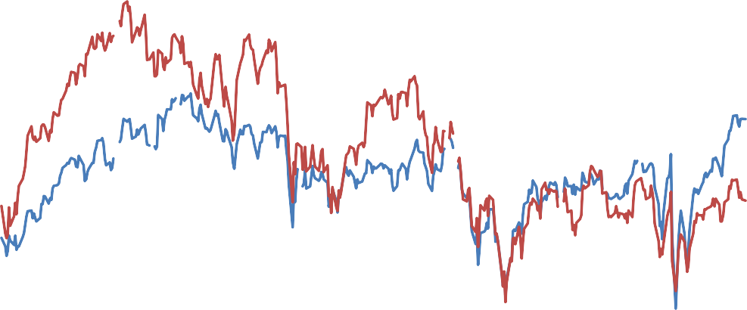

260

14000

280

15000

300

16000

320

17000

340

18000

380

360

EU

referendum

EU referendum date announcement

19000

400

DJ EURO STOXX (RHS)

20000

FTSE 250 (LHS)

Q1 1997

Q2 1997

Q3 1997

Q4 1997

Q1 1998

Q2 1998

Q3 1998

Q4 1998

Q1 1999

Q2 1999

Q3 1999

Q4 1999

Q1 2000

Q1 2008

Q2 2008

Q3 2008

Q4 2008

Q1 2009

Q2 2009

Q3 2009

Q4 2009

Q1 2010

Q2 2010

Q3 2010

Q4 2010

Q1 2011

**Figure 3. Changes in equity indices during periods of stress**

Note: ‘Other AEs’ excludes AEs in the euro area and the US.

US

Euro area Other AEs EMEs

80%

60%

40%

20%

0%

-20%

-40%

-60%

Note: ‘Asian crisis countries’ include: Thailand, Philippines, Indonesia, Malaysia, Hong Kong, South Korea, and Taiwan. ‘Other AEs’ excludes AEs in the EA and Asian crisis AEs. ‘Other EMEs’ excludes Asian crisis EMEs.

Asian crisis countries Euro area

Other AEs Other EMEs

80%

60%

40%

20%

0%

-20%

-40%

-60%

b. Global Financial Crisis

a. Asian Crisis

**Figure 4. GDP growth during periods of stress**

US

Euro area

Other AEs EMEs

%qoq 3

2

1

0

-1

-2

-3

-4

Asian crisis countries Other EMEs

Euro area

Other AEs

%qoq 3

2

1

0

-1

-2

-3

-4

b. Global Financial Crisis

a. Asian Crisis

14/06/1997

26/07/1997

06/09/1997

18/10/1997

29/11/1997

10/01/1998

21/02/1998

04/04/1998

16/05/1998

07/06/2008

19/07/2008

30/08/2008

11/10/2008

22/11/2008

03/01/2009

14/02/2009

28/03/2009

09/05/2009

**Figure 5. Bilateral equity correlations**

1. Equity Market Correlations: 1985-1994

EMEs

Euro area other AEs EMEs Note: white cells refer to countries without data for the period considered.

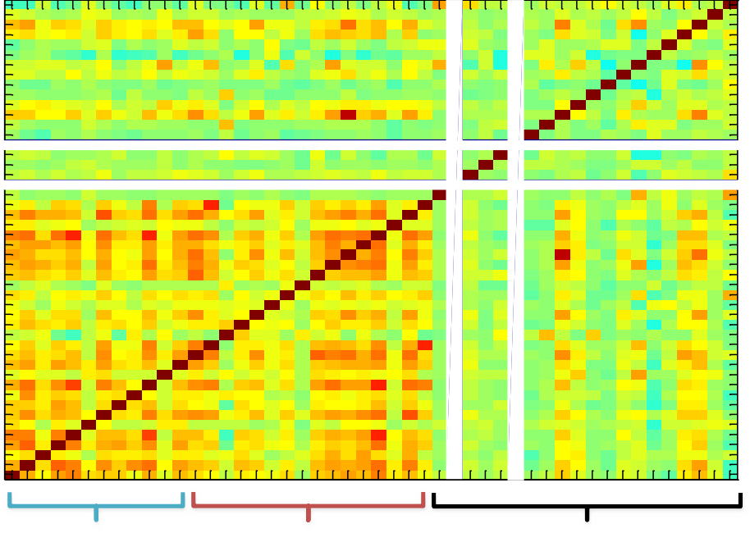

1985-1994

VE TK TH SA SI RS PO PH PE PK MX MY ID IN HN CB CH CL BR AG US UK TW SW SD SP NW NZ KO JP IS HK DK CZ CN AU ES PT NL LX IT IR GR BD FR FN BG OE

1

0.8

0.6

0.4

0.2

0

-0.2

-0.4

-0.6

-0.8

OE BG FN FR BD GR IR IT LX NL PT ES AU CN CZ DK HK IS JP KO NZ NW SP SD SW TW UK US AG BR CL CH CB HN IN ID MY MX PK PE PH PO RS SI SA TH TK VE

-1

other AEs

Euro area

1. Equity Market Correlations: 1995-2004

1995-2004

1

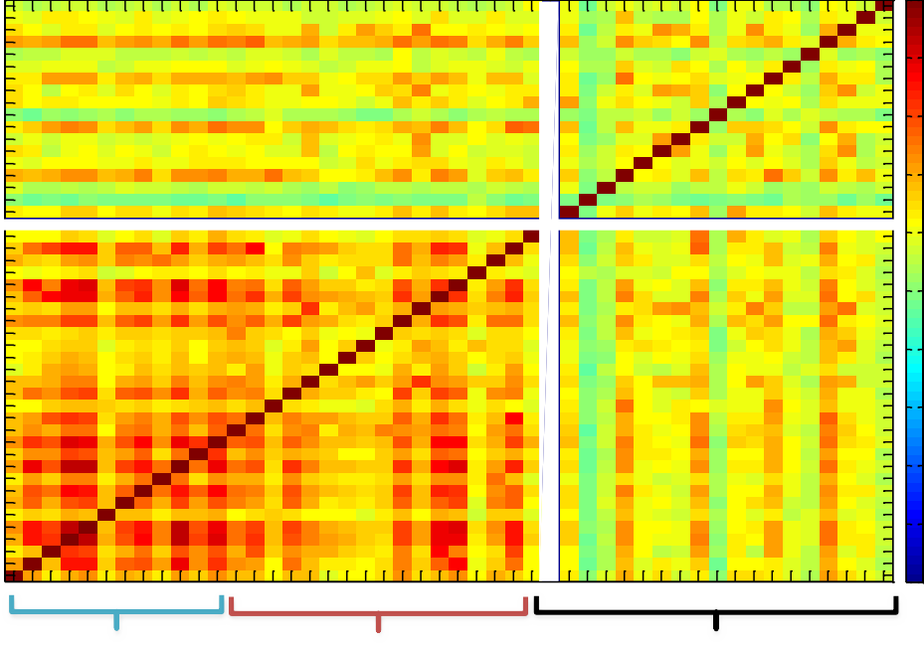

OE BG FN FR BD GR IR IT LX NL PT ES AU CN CZ DK HK IS JP KO NZ NW SP SD SW TW UK US AG BR CL CH CB HN IN ID MY MX PK PE PH PO RS SI SA TH TK VE

Euro area

other AEs

EMEs



VE TK TH SA SI RS PO PH PE PK MX MY ID IN HN CB CH CL BR AG US UK TW SW SD SP NW NZ KO JP IS HK DK CZ CN AU ES PT NL LX IT IR GR BD FR FN BG OE

0.8

0.6

EMEs

0.4

0.2

0

other AEs

-0.2

-0.4

-0.6

Euro area

-0.8

-1

1. Equity Market Correlations: 2008-2010

2008-2010

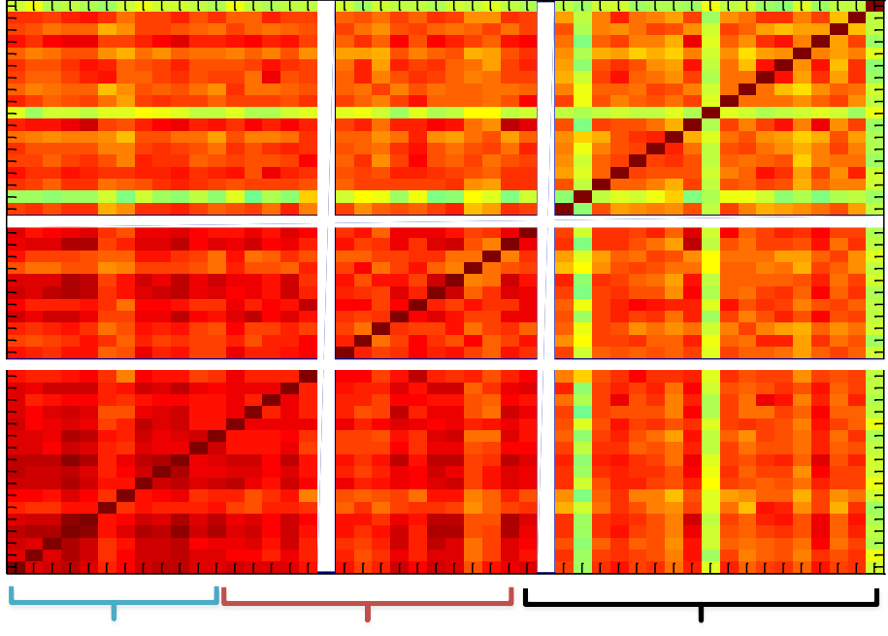VE TK TH SA SI RS PO PH PE PK MX MY ID IN HN CB CH CL BR AG US UK TW SW SD SP NW NZ KO JP IS HK DK CZ CN AU ES PT NL LX IT IR GR BD FR FN BG OE

Euro area

other AEs

EMEs

OE BG FN FR BD GR IR IT LX NL PT ES AU CN CZ DK HK IS JP KO NZ NW SP SD SW TW UK US AG BR CL CH CB HN IN ID MY MX PK PE PH PO RS SI SA TH TK VE

1

0.8

0.6

0.4

0.2

0

-0.2

-0.4

-0.6

-0.8

-1

Euro area

other AEs

EMEs

1. Equity Market Correlations: 2010-2016

Euro area

other AEs

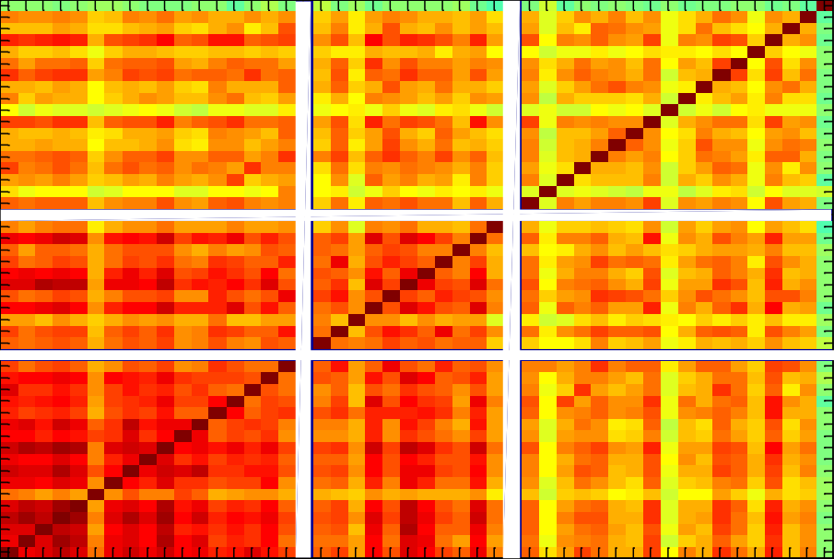2010-2016



VE TK TH SA SI RS PO PH PE PK MX MY ID IN HN CB CH CL BR AG US UK TW SW SD SP NW NZ KO JP IS HK DK CZ CN AU ES PT

NL

LX IT IR GR BD FR FN BG OE

EMEs

1



OE BG FN FR BD GR IR IT LX NL PT ES AU CN CZ DK HK IS JP KO NZ NW SP SD SW TW UK US AG BR CL CH CB HN IN ID MY MX PK PE PH PO RS SI SA TH TK VE

Euro area

other AEs

EMEs

0.8

0.6

0.4

0.2

0

-0.2

-0.4

-0.6

-0.8

-1

# Figure 6. Bilateral GDP Correlations

1. GDP Growth Correlations: 1985-1994

1985Q1-1994Q4

TK TH SA RS PO PH MX MY ID IN HN CB CL BR AG US UK TW SW SD SP NW NZ KO JP IS HK DK CZ CN AU ES PT NL LX IT IR GR BD FR FN BG OE

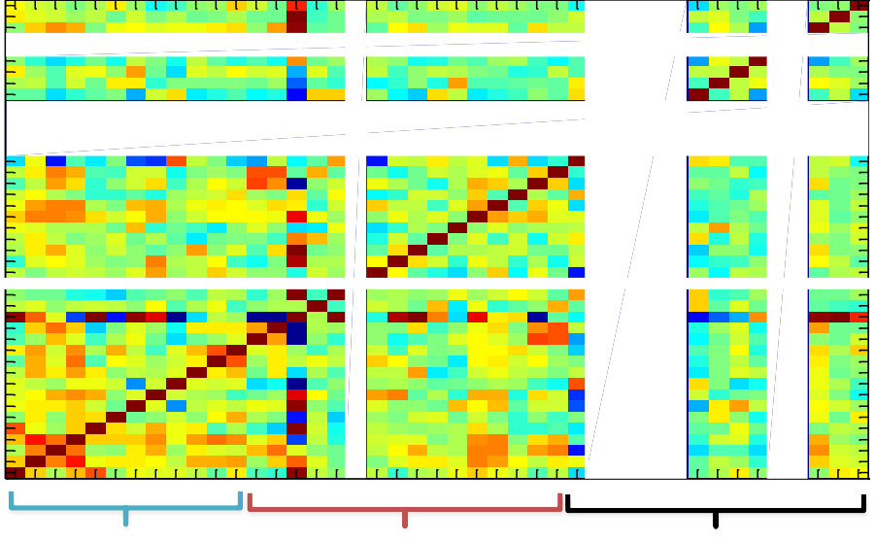

EMEs

Euro area

other AEs

OE BG FN FR BD GR IR IT LX NL PT ES AU CN CZ DK HK IS JP KO NZ NW SP SD SW TW UK US AG BR CL CB HN IN ID MY MX PH PO RS SA TH TK

1

0.8

0.6

0.4

0.2

0

-0.2

-0.4

-0.6

-0.8

-1

Euro area

other AEs EMEs

Note: white cells refer to countries without data for the period considered.

## GDP Growth Correlations: 1995-2004

1

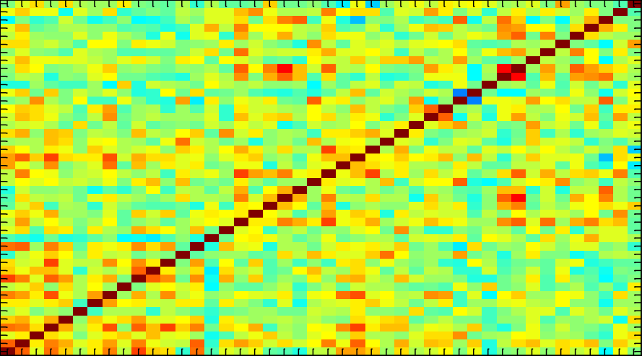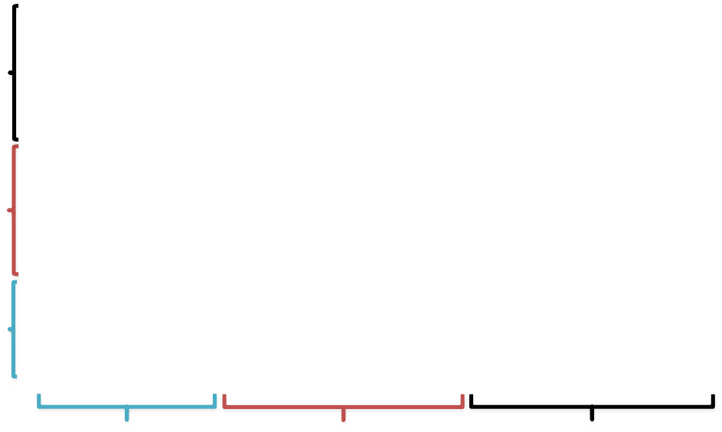

1995Q1-2004Q4

VE TK TH SA RS PO PH MX MY ID IN HN CB CL BR AG US UK TW SW SD SP NW NZ KO JP IS HK DK CZ CN AU ES PT NL LX IT IR GR BD FR FN BG OE

OE BG FN FR BD GR IR IT LX NL PT ES AU CN CZ DK HK IS JP KO NZ NW SP SD SW TW UK US AG BR CL CB HN IN ID MY MX PH PO RS SA TH TK VE

Euro area

other AEs

EMEs

0.8

0.6

EMEs

0.4

0.2

0

other AEs

-0.2

-0.4

-0.6

Euro area

-0.8

-1

1. GDP Growth Correlations: 2008-2011

1

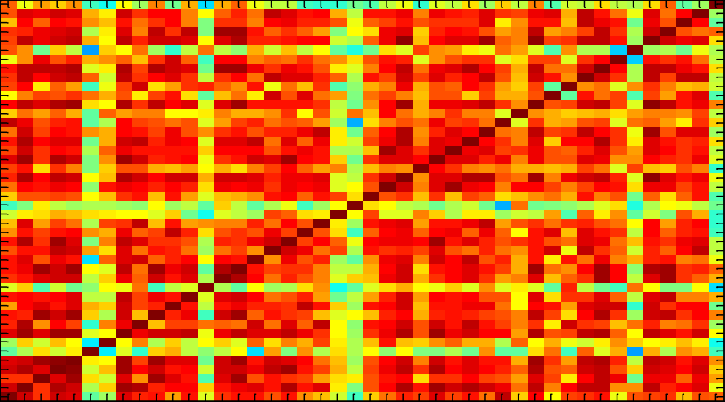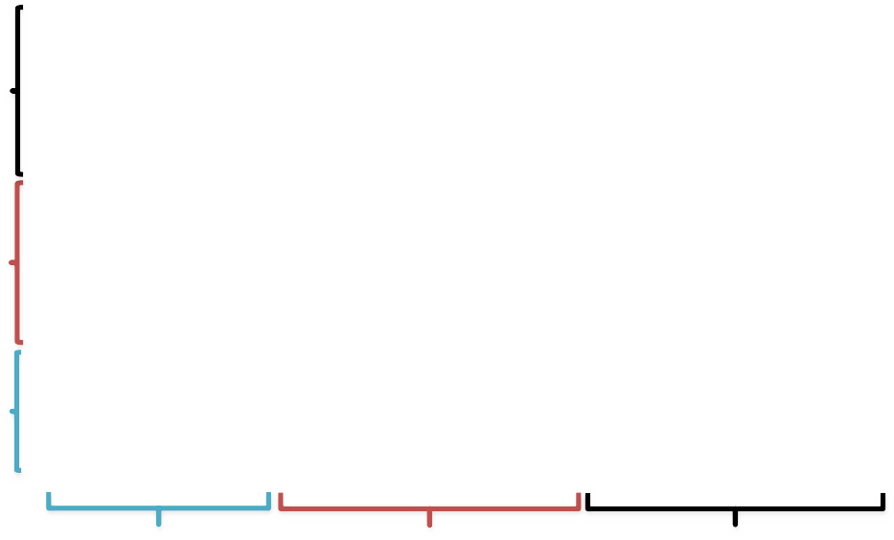

2008Q1-2011Q1

VE TK TH SA RS PO PH MX MY ID IN HN CB CL BR AG US UK TW SW SD SP NW NZ KO JP IS HK DK CZ CN AU ES PT NL LX IT IR GR BD FR FN BG OE

OE BG FN FR BD GR IR IT LX NL PT ES AU CN CZ DK HK IS JP KO NZ NW SP SD SW TW UK US AG BR CL CB HN IN ID MY MX PH PO RS SA TH TK VE

Euro area

other AEs

EMEs

0.8

EMEs

0.6

0.4

0.2

other AEs

0

-0.2

-0.4

Euro area

-0.6

-0.8

-1

1. GDP Growth Correlations: 2010-2016

1

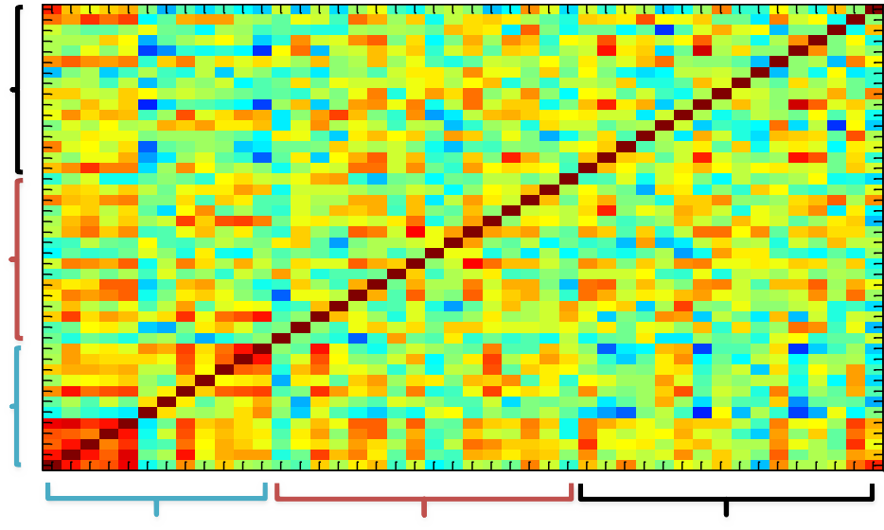

2010Q1-2016Q1

VE TK TH SA RS PO PH MX MY ID IN HN CB CL BR AG US UK TW SW SD SP NW NZ KO JP IS HK DK CZ CN AU ES PT NL LX IT IR GR BD FR FN BG OE

OE BG FN FR BD GR IR IT LX NL PT ES AU CN CZ DK HK IS JP KO NZ NW SP SD SW TW UK US AG BR CL CB HN IN ID MY MX PH PO RS SA TH TK VE

Euro area

other AEs

EMEs

0.8

EMEs

0.6

0.4

0.2

other AEs

0

-0.2

-0.4

Euro area

-0.6

-0.8

-1

1980

1985

1990

1995

2000

2005

2010

2015

1984

1987

1990

1993

1996

1999

2002

2005

2008

2011

2014

# Figure 7. Five-year rolling correlations in equity returns and GDP growth rates

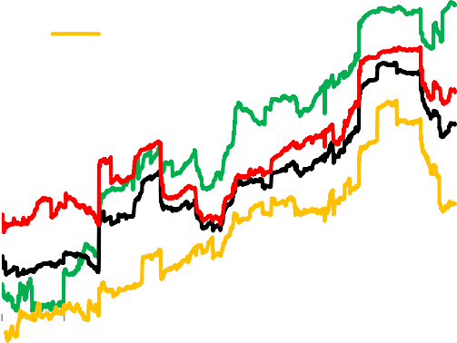

0.8

0.7

0.6

0.5

0.4

0.3

0.2

0.1

0

-0.1

Full sample Euro area

Other Advanced

Emerging Markets

1

0.9

0.8

0.7

0.6

0.5

0.4

0.3

0.2

0.1

0

-0.1

Euro area Full sample

Other Advanced

Emerging

b. GDP growth

a. Equity returns

**Figure 8. Five-year rolling standard deviations of equity returns and GDP growth rates**

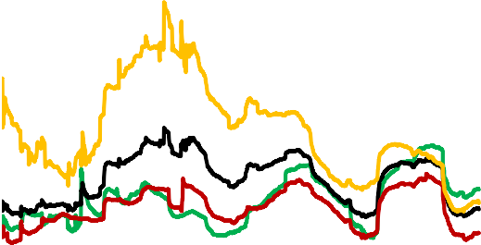

0

2.4

2

1.6

1.2

0.8

0.4

Full sample Euro area

Other advanced

Emerging markets

8

7

6

5

4

3

2

1

Euro area Full sample

Other advanced

Emerging markets

b. GDP growth

a. Equity returns

1980

1985

1990

1995

2000

2005

2010

2015

1985

1988

1991

1994

1997

2000

2003

2006

2009

2012

2015

**Figure 9. Share of variance explained by set of principal components**

## Equity returns b. GDP growth

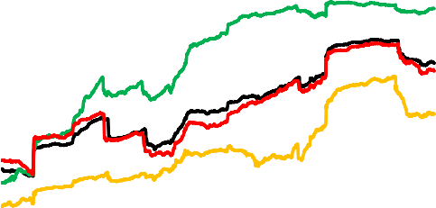

Full sample EA

Other advanced Emerging markets

1

0.8

0.6

0.4

0.2

Full sample Euro area Other advanced

Emerging markets

0.9

0.7

0.5

0 0.3

1985

1988

1991

1994

1997

2000

2003

2006

2009

2012

2015

1984

1987

1990

1993

1996

1999

2002

2005

2008

2011

2014

Note: The full sample includes 23 countries with weekly equity market data from 1980; of these, 5 are in the euro area, 5 are emerging markets and 13 are other advanced economies. A different number of principal components is selected for each country group by using the components which have an eigenvalue greater than 1 for the full sample period 1980- 2016. As a result, the full sample line shows the share of variance explained over time by the first 3 principal components; the euro area sample - by the first component; the other advanced group - by the first two principal components; and the emerging markets group - by the first principal component only.

Note: The full sample includes 31 countries with quarterly GDP growth data from 1980; of these, 12 are in the euro area, 5 are emerging markets and 14 are other advanced economies. A different number of principal components is selected for each country group by using the components which have an eigenvalue greater than 1 for the full sample period 1980-2016. As a result, the full sample line shows the share of variance explained over time by the first 5 principal components; the euro area sample - by the first 2 components; the other advanced group - by the first 5 principal components; and the emerging markets group - by the first 3 principal components.

1985

1988

1991

1994

1997

2000

2003

2006

2009

2012

2015

1984

1987

1990

1993

1996

1999

2002

2005

2008

2011

2014

# Figure 10. Weighted average of five-year rolling standard deviation of principal components

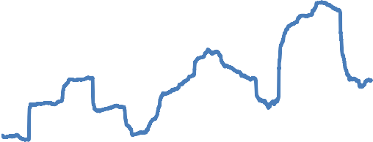

Note: Average is of first five principal components and the weights reflect the share of variance explained by those. See note on Figure 9 for further detail on the full country sample.

Weighted average of rolling standard deviations of common factors 5.0

4.0

3.0

2.0

1.0

0.0

Note: Average is of first three principal components and the weights reflect the share of variance explained by those. See note on Figure 9 for further detail on the full country sample.

Weighted average rolling standard deviation of common factors 5.0

4.0

3.0

2.0

1.0

0.0

b. GDP growth

a. Equity returns

1985

1988

1991

1994

1997

2000

2003

2006

2009

2012

2015

1984

1987

1990

1993

1996

1999

2002

2005

2008

2011

2014

**Figure 11. Average absolute loading and standard deviation of loadings on common factors from rolling principal component analysis (5-year rolling window)**

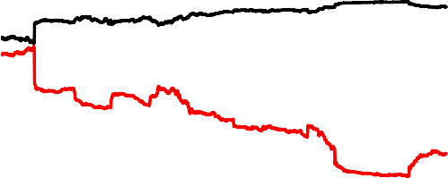

Weighted loadings on first 5 components; full sample includes **32** countries with data from 1980 (Austria, Belgium, Finland, France, Germany, Greece, Ireland, Italy, Luxemburg, Netherlands, Portugal, Spain, Malaysia, Mexico, Philippines, South Africa, Thailand, Australia, Canada, Denmark, Hong Kong, Japan, South Korea, New Zealand, Norway, Singapore, Sweden, Switzerland, Taiwan, UK and US).

0.18

0.16

0.14

0.12

0.10

0.08

0.06

0.04

0.02

0.00

Avg abs loading Stdev loading

Weighted loadings on first 3 components; full sample includes **23** countries with data from 1980 (France, Germany, Italy, Netherlands, Spain, Argentina, Chile, India, Malaysia, Thailand, Australia, Canada, Denmark, Hong Kong, Japan, South Korea, New Zealand, Singapore, Sweden, Switzerland, Taiwan, UK and US).

0.25

0.20

0.15

0.10

0.05

0.00

Avg abs loading Stdev loading

b. GDP growth

a. Equity returns

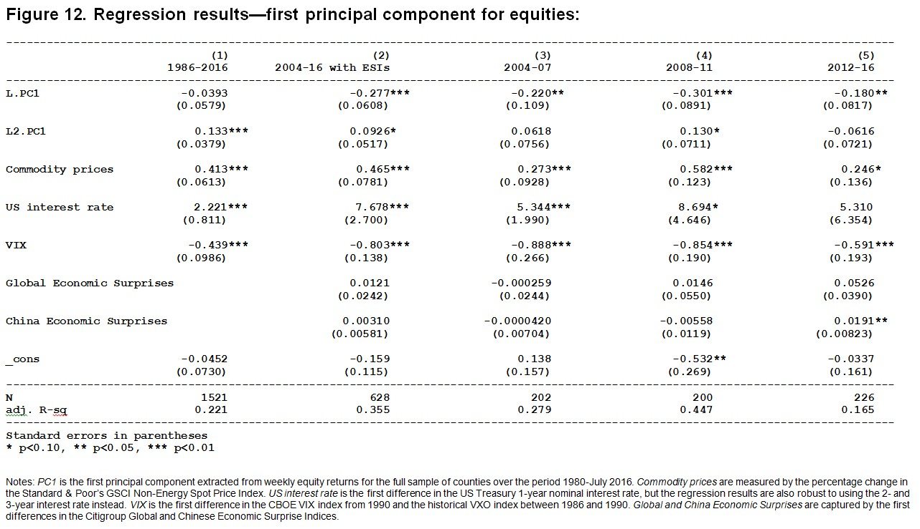

1980

1982

1985

1988

1991

1994

1997

2000

2003

2006

2009

2012

2015

1980

1983

1986

1989

1992

1995

1998

2001

2004

2007

2010

2013

2016

**Figure 13. Share of variance explained by first principal component**

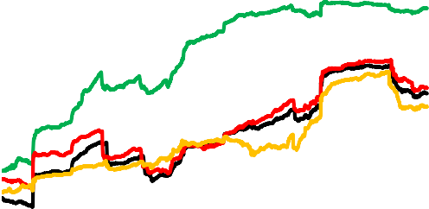

Note: Country samples are the same as in Figure 9.

1

0.8

0.6

0.4

0.2

0

Full sample Euro area Other advanced

Emerging markets

Note: Country samples are the same as in Figure 9.

1

0.8

0.6

0.4

0.2

0

Full sample Euro area Other advanced

Emerging markets

b. GDP

a. Equity

**Figure 14. Extreme Negative Returns for equities GDP growth**

100

90

80

70

60

50

40

30

20

10

0

b. GDP growth

a. Equity returns

100

90

80

70

60

50

40

30

20

10

0

1985

1988

1991

1994

1997

2000

2003

2006

2009

2012

2015

1984

1987

1990

1993

1996

1999

2002

2005

2008

2011

2014

**Figure 15. Average % of sample with Extreme Negative Return (ENR) in equity and growth**

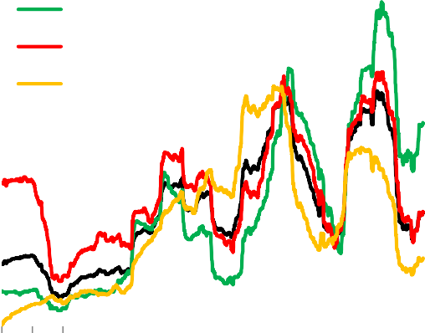

0

5

10

15

Emerging markets

Other advanced

20

Full sample

Euro Area

0

12

10

8

6

4

2

Full sample Euro area Other advanced

Emerging markets

b. GDP ENR (5-year rolling averages)

a. Equity ENR (5-year rolling averages)

**Figure 16. Extreme Negative Return (ENR) regressions for equity with openness interactions**

1974

1977

1980

1983

1986

1989

1992

1995

1998

2001

2004

2007

2010

2013

1984

1987

1990

1993

1996

1999

2002

2005

2008

2011

2014

|  |  |  |  |  |  |  |
| --- | --- | --- | --- | --- | --- | --- |
| **(1)** | | | **(2)** | **(3)** | **(4)** | **(5)** |
| **ENR** | | | **ENR** | **ENR** | **ENR** | **ENR** |
| **Commodity prices** | | **0.0158\*\*** | **0.0295\*\*\*** | **0.0280\*\*\*** | **0.0136** | **0.0184\*** |
|  | | **(0.00770)** | **(0.00774)** | **(0.00681)** | **(0.00905)** | **(0.0107)** |
| **VIX** | | **0.00594** (0.00286)** | **0.0158*** (0.00203)** | **0.0219*** (0.00162)** | **0.00874*** (0.00278)** | **0.0107*** (0.00297)** |
| **US interest rate** | | **0.396** (0.163)** | **0.309** (0.150)** | **0.561*** (0.136)** | **0.547*** (0.165)** | **0.632*** (0.200)** |
| **ENR*All*** | | **0.0582*** (0.00225)** |  |  |  |  |
| **ENR*All*** | **_Leverage** | **0.0248*** (0.00345)** | | **0.0129*** (0.00315)** | | |

**ENR*All* ENR*All***

|  |  |  |  |
| --- | --- | --- | --- |
| **_Trade** | **0.000603*** (0.0000892)** | **0.000456*** (0.0000388)** | |
| **_FinOpennes** | **0.0648*** (0.00284)** | | **0.0473*** (0.00500)** |

|  |  |  |  |  |  |
| --- | --- | --- | --- | --- | --- |
| **_cons** | **-3.726*** (0.0709)** | **-3.533*** (0.0630)** | **-3.402*** (0.0429)** | **-3.644*** (0.0699)** | **-3.692*** (0.0755)** |
| **N** | **71534** | **59000** | **55216** | **67023** | **47278** |

**Standard errors in parentheses**

**\* p<0.10, ** p<0.05, *** p<0.01**

Notes: See the notes to Figure 12 for a description of the first three global variables. 𝑇𝑟𝑎𝑑𝑒 is measured as (exports+imports)/GDP.

𝐹𝑖𝑛𝑂𝑝𝑒𝑛𝑛𝑒𝑠𝑠 is measured using the normalized Chinn-Ito measure of capital account openness. 𝐵𝑎𝑛𝑘𝐿𝑒𝑣𝑒𝑟𝑎𝑔𝑒 is measured using the ratio of domestic banks’ claims on the private sector to the value of demand, time, savings and foreign currency deposits, using data from the IMF International Financial Statistics database.

# Figure 17a. Under Mannen Bridge at Fukagawa by Katsushika Hokusai



**Figure 17b. Shore of Tago Bay by Katsushika Hokusai**



1985

1987

1989

1991

1993

1995

1997

1999

2001

2003

2005

2007

2009

2011

2013

2015

1984

1986

1988

1990

1992

1994

1996

1998

2000

2002

2004

2006

2008

2010

2012

2014

1984

1986

1988

1990

1992

1994

1996

1998

2000

2002

2004

2006

2008

2010

2012

2014

1984

1986

1988

1990

1992

1994

1996

1998

2000

2002

2004

2006

2008

2010

2012

2014

**Appendix**

## Average absolute loading and standard deviation of loadings on common factors from rolling principal component analysis (with 5-year rolling window)

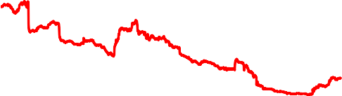

Weighted loadings on first 5 components; sample includes 13 countries with data from 1980 (Australia, Canada, Denmark, Hong Kong, Japan, South Korea, New Zealand, Norway, Singapore, Sweden, Switzerland, Taiwan, UK and US).

0.35

0.30

0.25

0.20

0.15

0.10

0.05

0.00

Avg abs loading

Stdev loading

Weighted loadings on first 2 components; sample includes 14 countries with data from 1980 (Australia, Canada, Denmark, Hong Kong, Japan, South Korea, New Zealand, Singapore, Sweden, Switzerland, Taiwan, UK and US).

0.30

0.25

0.20

0.15

0.10

0.05

0.00

Avg abs loading Stdev loading

d. GDP, Other advanced economies

c. Equities, Other advanced economies

Weighted loadings on first 2 components; sample includes 12 countries with data from 1980 (Austria, Belgium, Finland, France, Germany, Greece, Ireland, Italy, Luxemburg, Netherlands, Portugal and Spain).

0.30

0.25

0.20

0.15

0.10

0.05

0.00

Avg abs loading

Stdev loading

Weighted loadings on first 1 component; sample includes **5** countries with data from 1980 (France, Germany, Italy, Netherlands and Spain).

0.50

0.45

0.40

0.35

0.30

0.25

0.20

0.15

0.10

0.05

0.00

Avg abs loading

Stdev loading

b. GDP, Euro area countries

a. Equities, Euro area countries



Weighted loadings on first 3 components; sample includes 5 countries with date from 1980 (Malaysia, Mexico, Philippines, South Africa and Thailand).

0.60

0.50

0.40

0.30

0.20

0.10

0.00

Avg abs loading

Stdev loading

Weighted loadings on first 1 component; sample includes 5 countries with data from 1980 (Argentina, Chile, India, Malaysia and Thailand).

0.60

0.50

0.40

0.30

0.20

0.10

0.00

Avg abs loading

Stdev loading

f. GDP, Emerging markets

e. Equities, Emerging markets

1985

1987

1989

1991

1993

1995

1997

1999

2001

2003

2005

2007

2009

2011

2013

2015

1984

1986

1988

1990

1992

1994

1996

1998

2000

2002

2004

2006

2008

2010

2012

2014